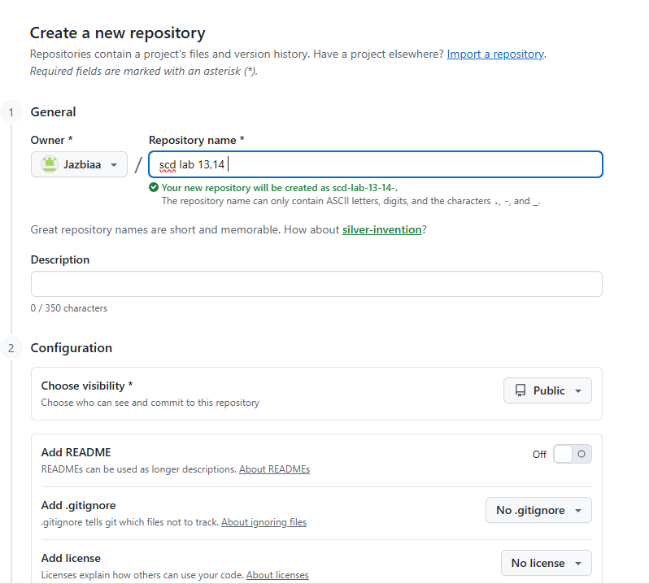

public class PrintOddNumbers {
public static void main(String[] args) {

for (int i = 1; i <= 10; i++) {
if (i % 2 != 0) {
System.out.println(i);
}
}

}
}

